Docs/retiver.py
Section
========================================================================MAIN RETRIEVER
This is production-grade retrieval orchestration system
You have
• hybrid retrieval
• reranking
• corrective RAG
• agent-specific retrieval
• metadata filtering
• context formatting
• deduplication
• caching

brain controlling retrieval flow
It decides:
- which retrieval strategy to use
- which documents to search
- how to rerank
- how to self-correct
- how to format context for LLM
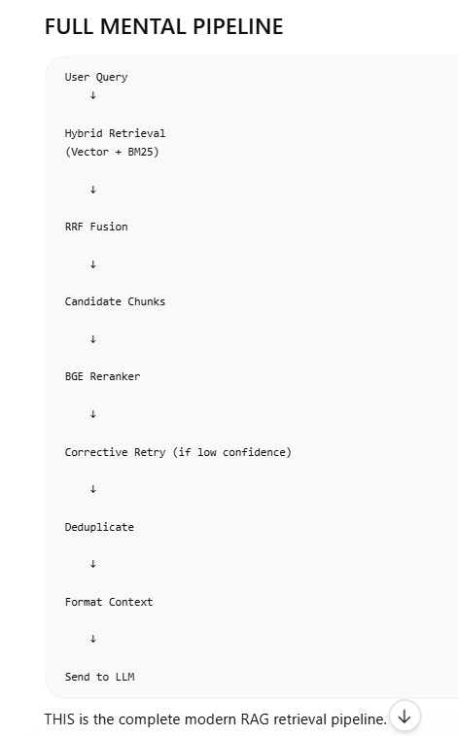

Concept 1
--------------
Domain Terms , What is this:
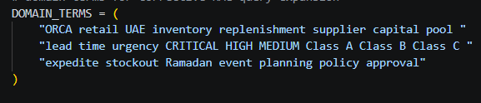
This is:
query expansion vocabulary
Used when retrieval quality poor.
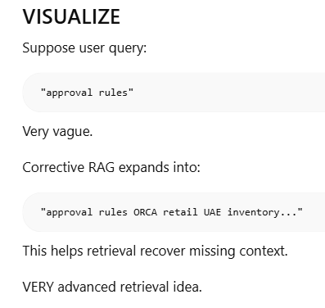

Concept 2
--------------
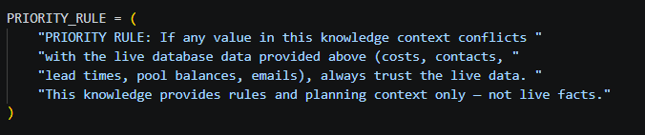
PRIORITY_RULE
This is:
anti-hallucination instruction
VERY enterprise-style.
